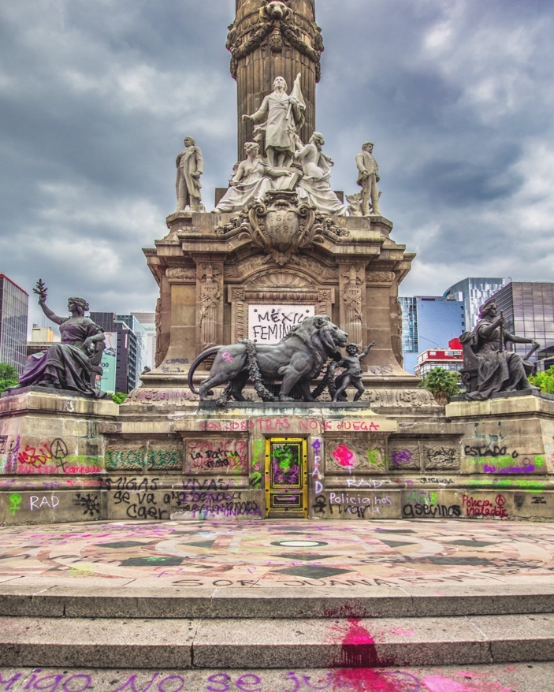

los cubrebocas, y la oms

espacios cerrados Concurrido

o cualquier espacio cerrado donde no estamos seguros del Sistema de ventilación,

1 m distancia

limpieza de mano

cubrir tos o estornuds

abrir ventanas

**All about masks in the context of COVID-19**

Masks should be used as part of a comprehensive strategy of measures to suppress transmission and save lives; the use of a mask alone is not sufficient to provide an adequate level of protection against COVID-19.

If COVID-19 is spreading in your community, stay safe by taking some simple precautions, such as physical distancing, wearing a mask, keeping rooms well ventilated, avoiding crowds, cleaning your hands, and coughing into a bent elbow or tissue. Check local advice where you live and work. **Do it all!**

**Make wearing a mask a normal part of being around other people. The appropriate use, storage and cleaning or disposal of masks are essential to make them as effective as possible.**

Here are the basics of [how to wear a mask](https://youtu.be/ciUniZGD4tY):

* Clean your hands before you put your mask on, as well as before and after you take it off, and after you touch it at any time.
* Make sure it covers both your nose, mouth and chin.
* When you take off a mask, store it in a clean plastic bag, and every day either wash it if it’s a fabric mask, or dispose of a medical mask in a trash bin.